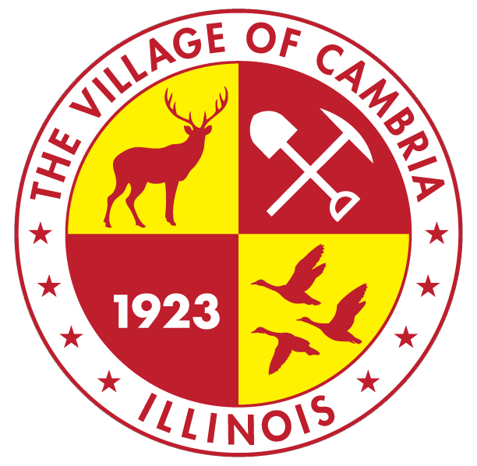

VILLAGE OF CAMBRIA
Police Merit Board

October 13, 2026
Meeting Minutes

Chairman Matt called the meeting to order at 4:30

Rollcall: All Members Present

Approve Minutes: Motion was made by Tom Lafond and seconded by Robbie Chitwood to approve September meeting minutes.

Approve Executive Minutes: NONE

Guest on Agenda: NONE

New Business:
- Adopt hiring practices. Motion made by Tom Lafond and seconded by Robbie Chitwood to formalize the published guidelines.
- Set application timeline/discuss if extra meeting is needed for interviews: By unanimous agreement, The Merit Board will convene a Special Meeting Tuesday October 27 at 4:30 to begin applicant interviews. Should additional time be required to complete the interviews, an additional date will be set.

Matt indicated that his plans are to present a full applicant listing to the Village Board at the Board’s December, 2026 meeting.
- Discuss/adopt forms for use. The board discussed the proposed new Application form, interview questions form and the interview Scoresheet.

It was determined that at the respective interviews, a number of interview questions will be selected from the potential list of 38. Those selected questions will be used consistently throughout all future interviews with the option to utilize additional clarification questions as needed.

Tom Lafond made a motion to accept the submitted forms with the interview scoresheet modified to add 2 additional points if the applicant is a veteran. Carlee seconded the motion.

Matt concluded the meeting indicating the Village Board has asked the Merit Board to consider reviewing current police parameters. No decision was made at this time.

The meeting adjourned at 4:52

