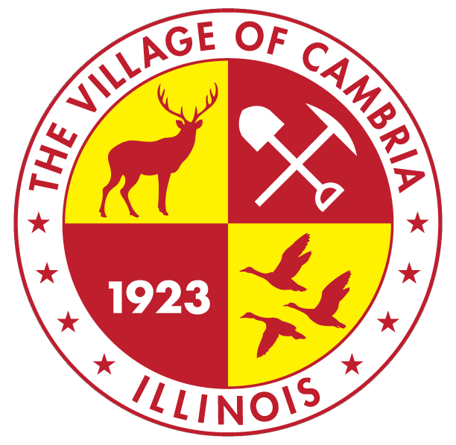

VILLAGE OF CAMBRIA
Merit board meeting
October 13th , 2026
Meeting Starts at 4:30 PM at Village Community Building

ROLL CALL

APPROVE MINUTES

APPROVE EXECUTIVE MINUTES- NONE

GUEST ON AGENDA:

NEW BUSINESS:
- Adopt hiring practices
- Set application timeline
- Discuss interview dates/times
- Discuss if extra meeting is needed for interviews
- Discuss/ adopt forms for use

EXECUTIVE SESSION: (If needed)

